Osetreni zavirani zavreni aplikace HandleClosing

**Admin ShellView**:

<Window

x:Class="MIR.Media.Admin.Shell.ShellView" ...

Micro:Message.Attach="[Event Closing] = [Action HandleClosing($eventArgs)]"

**Admin ShellViewModel**:

public void HandleClosing(CancelEventArgs args)

{

ICanPreventClosing[] canPrevents = Items.Where(i => i is ICanPreventClosing).Cast<ICanPreventClosing>().ToArray();

foreach (ICanPreventClosing item in canPrevents)

{

if (item.PreventsClosing())

{

MessageBoxResult result = MessageBox.Show(string.Format("{0} {1}", item.ReasonToPreventClosing, Localisation.CloseAppAnyway), Localisation.Warning, MessageBoxButton.YesNo, MessageBoxImage.Warning);

if (result == MessageBoxResult.No)

{

args.Cancel = true;

break;

}

}

}

}

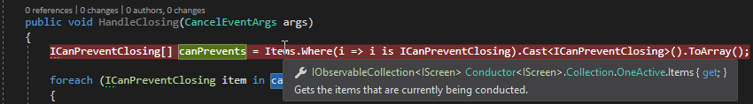

**Kodovadlo ShellViewModel:**

public void HandleClosing(CancelEventArgs args)

{

if (MessageBox.Show(Localisation.DoYouReallyWantToCloseApplication, string.Empty, MessageBoxButton.OKCancel) == MessageBoxResult.Cancel)

{

args.Cancel = true;

}

}